Data Visualization
With Python
A comprehensive learning journey
From Theory to Practice
Dice, Distributions & Dynamics

By Faizan Toheed
1/19/2026

Table of Contents
Part 1: Simple Line Graphs & Scatter Plots (Matplotlib) 3
1. Plotting a Simple Line Graph 3
2. Scatter Plots & Individual Points 3
3. Automating Data 3
4. Customizing the Look (Colormaps) 4
Part 2: Random Walks (The Simulation) 4
1. The Logic: RandomWalk Class 4
2. Visualizing with Matplotlib (Standard) 4
Part 3: Rolling Dice (The Distributions) 4
1. The Logic: Die Class 4
2. Visualizing with Plotly (Standard) 5
3. Advanced Simulations 5
Part 4: The "Reverse" Challenges 5
Challenge A: Random Walk in Plotly 5
Challenge B: Rolling Dice in Matplotlib 5
Part 5: Code Efficiency & Troubleshooting Log 6
1. Common Errors & Fixes (Cheat Sheet) 6
2. Syntax Reference Table 6

Part 1: Simple Line Graphs & Scatter Plots (Matplotlib)
The foundation of data visualization using the matplotlib.pyplot library.

Plotting a Simple Line Graph
- Function: plt.plot(input_values, squares)
- Logic: Connects points with a line. Great for showing trends over time.
- Key Customizations:
- Title: plt.title("Title", fontsize=24)
- Labels: plt.xlabel("Value") and plt.ylabel("Square of Value")
- Tick Size: plt.tick_params(axis='both', labelsize=14)

Scatter Plots & Individual Points
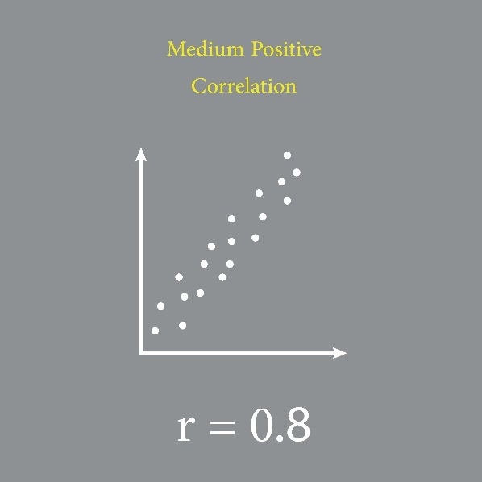
- Function: plt.scatter(x_values, y_values, s=10)
- Logic: Plots individual dots. Great for showing distribution or "clouds" of data.
- Key Arguments:
- s=10: Sets the size of the dots.
- edgecolor='none': Removes the black outline around dots (crucial when plotting thousands of points).

Automating Data
Instead of typing lists manually [1, 2, 3], use Python loops:

Customizing the Look (Colormaps)
To make points fade from light to dark based on their value (a gradient):
- Argument: c=y_values (Tell Python which list determines the color).
- Map: cmap=plt.cm.Blues (Tell Python which color scale to use).
- Code:

Part 2: Random Walks (The Simulation)
Simulating a path that has no clear direction (chaos).

The Logic: RandomWalk Class
- __init__: Initializes two lists, self.x_values = [0] and self.y_values = [0].
- fill_walk(): The main loop. It runs until the list reaches the desired length (e.g., 5,000 points).
- get_step(): (Refactoring Tip) It is cleaner to move the logic for "direction" and "distance" into its own method to keep fill_walk readable.

Visualizing with Matplotlib (Standard)
- Gradient: We use c=point_numbers (a list from 0 to 4999) to show the order of steps (Light Blue = Start, Dark Blue = End).
- Start/End Points: We plot point 0 (Green) and point -1 (Red) separately with a larger size to highlight them.
- Hiding Axes: To make it look like a piece of art, we remove the chart borders:
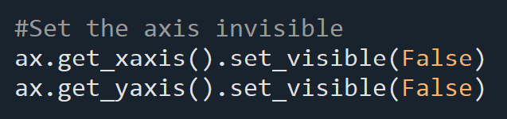

Part 3: Rolling Dice (The Distributions)
Simulating probability using the plotly library.

1. The Logic: Die Class
- __init__: Takes num_sides (default is 6).
- roll(): Returns randint(1, self.num_sides).

2. Visualizing with Plotly (Standard)
- Why Plotly? It creates interactive HTML files where you can hover over bars to see exact data.
- The Analysis Loop:
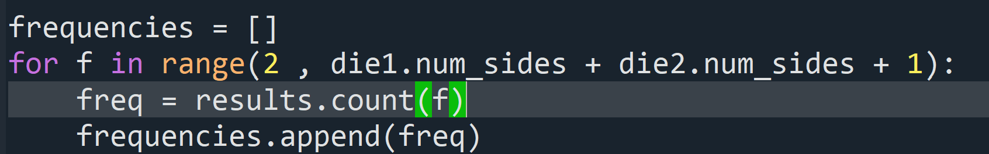
- Configuration (dtick): By default, Plotly might label the axis "2, 4, 6...". To force it to show "2, 3, 4, 5...", use:

3. Advanced Simulations
- Two Dice (Addition): Creates a Bell Curve (Triangle shape). 7 is the most common sum.
- Different Sizes (D6 + D10): Creates a Plateau. There is an equal chance for a range of middle numbers.
- Multiplication: Creates a graph with Gaps. You cannot roll a 7 or 11 by multiplying integers.

Part 4: The "Reverse" Challenges
Applying what you learned by swapping the libraries.

Challenge A: Random Walk in Plotly
- Goal: Create an interactive walk where you can zoom in.
- The Problem (Pandas Error): px.scatter usually expects a Pandas DataFrame. If you pass raw lists, it might crash if Pandas isn't installed.
- The Fix: Explicitly label your inputs as x= and y=.

Challenge B: Rolling Dice in Matplotlib
- Goal: Create a static, publication-ready bar chart.
- The Problem (Title Error): ax.title(...) crashes with TypeError: 'Text' object is not callable.
- The Logic:
- ax.title is a Noun (it holds the text of the title).
- ax.set_title is a Verb (the command to change the title).

Part 5: Code Efficiency & Troubleshooting Log

Common Errors & Fixes (Cheat Sheet)
Error Message | Cause | Fix
TypeError: 'Text' object is not callable | You used ax.title() instead of ax.set_title(). | Change to ax.set_title().
NotImplementedError: ... convert data_frame | You passed lists to px.scatter without x= and y= labels, and you don't have Pandas. | Add x= and y= keywords or install Pandas.
ValueError: Invalid property path 'my_layout' | You tried to pass a dictionary key named my_layout into offline.plot. | The key inside offline.plot must be exactly 'layout'.
TypeError: 'list' object cannot be interpreted as an integer | You put range(die.roll()). | Use range(die.num_sides). Never put a roll in a range function.

Syntax Reference Table
Feature | Matplotlib Command | Plotly Command
Scatter Plot | plt.scatter(x, y) | px.scatter(x=x, y=y)
Bar Chart | plt.bar(x, height) | px.bar(x=x, y=y)
Set Title | ax.set_title("Text") | layout = Layout(title="Text")
Set Axis Label | ax.set_xlabel("Text") | xaxis={'title': 'Text'}
Show Graph | plt.show() | offline.plot(...)

